# ACS 560 Software Engineering

# Homework 06

# (Ashwini Kulkarni)

Description BlackJack Game Java Program:

**Assumptions:**

* Ace can be consider as 1 or 11
* There are total 5 players.
* Testing Class will show Simulation
* Character Information
* D stands for Diamond
* H stands for Hearts
* S stands for Spade
* C stands for Club

1. Use the Class Diagram (UML) to show the relationships of core objects in the Step 3.

**Class Diagram is on next page**

1. Use Java to implement the core classes (i.e., Card, Hand, Deck, BlackJackCard, BlackJackHand, and BlackJackGameAutomator) in the Step 4.
2. Write a testing class (contain the main method) to test your implementation. For example, this testing class can simulate 5 players playing the BlackJack game and show who is the winner:

:- Created Testing Class for Testing simulation

Output:

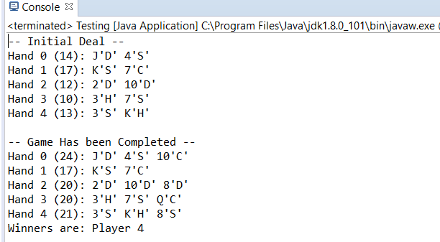

Class Diagram

